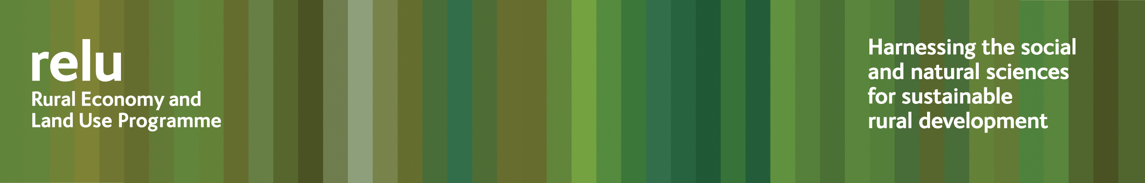

PRESS RELEASE

25 October 2010

Big Society could play a role in reformed CAP say researchers

Reform of the Common Agricultural Policy could play a key role in ensuring that land provides the wide range of public benefits we need from it, according to research carried out by the UK Research Councils’ Rural Economy and Land Use Programme.

In an in-depth examination of interdisciplinary research from across the programme, Land Use Consultant Alan Woods has drawn out some key opportunities offered in this important revamp of European policy.

He concludes that agri-environment schemes should stay, but need to be targeted more effectively to support farmers in delivering a wider range of services over a bigger area of land. Our use of land has to be economically and ecologically efficient.

This can only be achieved if schemes are applied at the right scale, which may mean considering whole landscapes rather than individual land holdings. So schemes would be more effective if they encouraged farmers to act as a community, rather than as individuals.

Timescales are also important and in the past there has been too much emphasis on short-term benefits which may be lost after five to ten years. A reformed CAP should be encouraging long-term delivery of valued services.

Relu’s new publication, ”Informing the Reform and Implementation of the Common Agricultural Policy”, shows that it is only by refocusing agri environment schemes as a cornerstone of a new Common Agricultural Policy that our limited supply of land can provide everything we need in an era of climate change.

Author Alan Woods said: “Relu research shows us that by taking an ecosystem services approach, we can get a much better return from land. That includes not only goods such as food and water, to which we can easily give a market value, but also environmental public goods, including carbon storage, wildlife and landscapes, that are important, but difficult to price.

“A Big Society outlook could help, by providing incentives for landowners to deliver a joined-up approach to soil, water and biodiversity, across ownership boundaries. Rather than each negotiating individual agreements with the Government, it would be more effective for them to work together to provide the services that will most benefit their local environment.

“Relu research has come up with some great examples of how farmers and rural communities can, themselves, identify challenges and opportunities and develop coordinated proposals to deliver ecosystem services. A reformed CAP provides a rare chance for us to facilitate this kind of approach.”

Allan Buckwell, Policy Director at the Country Land and Business Association added: “Relu provides an important body of the research and evidence to guide rural policy in Britain – and Europe. The programme has helpfully assembled and distilled the messages from its research for the Common Agricultural Policy.

“This policy does hold the resources and reach over a wide range of agricultural environmental and rural development issues. The Relu paper “Informing the Reform and Implementation of the Common Agricultural Policy” is a valuable analysis of CAP relevant research which provides interesting conclusions for the future development of policy”.

Notes for editors:

- ”Informing the Reform and Implementation of the Common Agricultural Policy” may be downloaded from the Relu website The Rural Economy and Land Use Programme is an interdisciplinary collaboration between the Economic and Social Research Council (ESRC), the Biotechnology and Biological Sciences Research Council (BBSRC) and the Natural Environment Research Council (NERC), with additional funding provided by the Scottish Government and Defra. See www.relu.ac.uk for more information about the Relu programme.
- More information about Relu research may be found at http://www.relu.ac.uk/research/
- For more information contact Anne Liddon, Science Communications Manager, tel 0191 222 6903 email anne.liddon@ncl.ac.uk.

ends

